**Source code with Output –**

import pandas as pd

import numpy as np

import matplotlib.pyplot as plt

import matplotlib.figure

import seaborn as sns

df = pd.read_csv('Medals.csv')

df

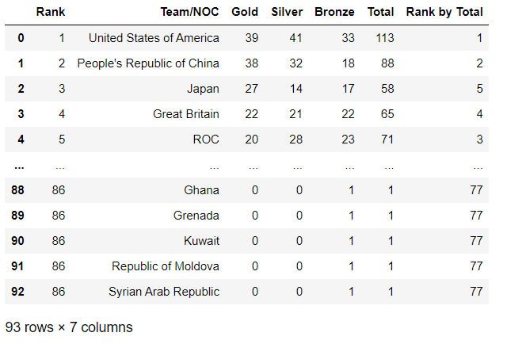

df.head()

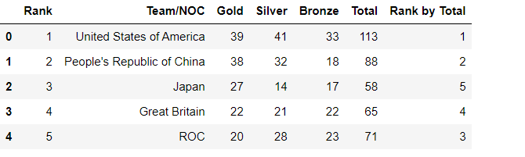

df.tail()

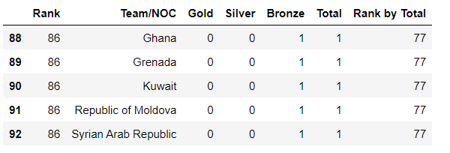

df.isnull()

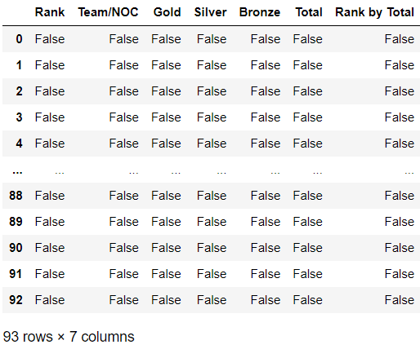

df.notnull().sum()

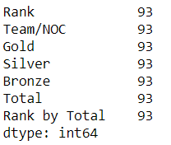

df.value_counts()

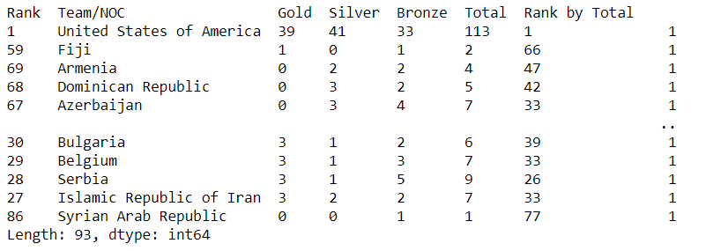

x = df['Team/NOC']

y1 = df['Gold']

y2 = df['Silver']

y3 = df['Bronze']

plt.figure(figsize=(50,40))

plt.xticks(fontsize=30)

plt.yticks(fontsize=30)

plt.xlabel('xlabel',fontsize=60)

plt.ylabel('ylabel',fontsize=60)

plt.bar(x, y1, color='y')

plt.bar(x, y2, bottom=y1, color='g')

plt.bar(x, y3, bottom=y1+y2, color='b')

plt.xticks(rotation=90)

plt.xlabel("Teams")

plt.ylabel("Medals")

plt.legend(["Gold", "Silver", "Bronze"],fontsize=60)

plt.title("Medals Scored by Teams", fontsize=60, fontweight='bold')

plt.show()

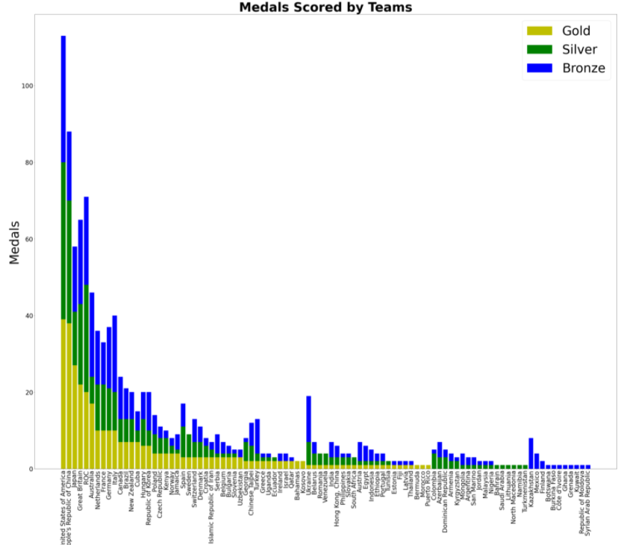

plt.figure(figsize=(50,40))

sns.set(font_scale=3)

plt.xticks(rotation=90)

sns.scatterplot(x='Team/NOC',y='Gold',data=df)

sns.lineplot(x='Team/NOC',y='Silver',data=df)

sns.barplot(x='Team/NOC',y='Bronze',data=df)

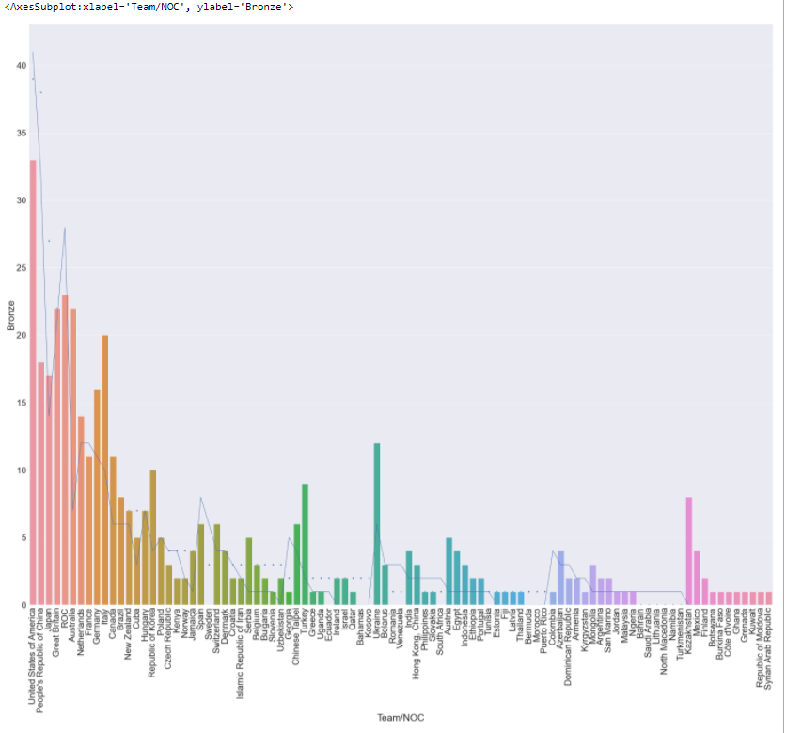

df.groupby('Team/NOC').sum()[['Gold','Silver','Bronze']].sort_values('Gold',ascending=False).reset_index()

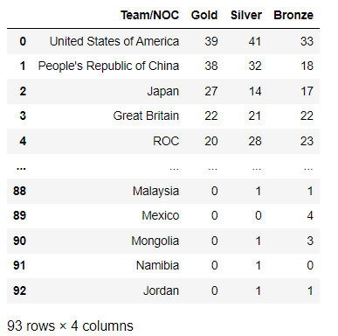

inp = input('Enter Country name here :')

m = df.groupby(['Team/NOC'])

inpt = m.get_group(inp)

inpt

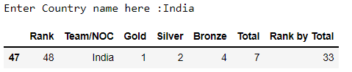

DataFrame = pd.DataFrame(data=m.get_group(inp))

f = pd.DataFrame({'value': [4.330, 5.87, 6.97]})

DataFrame.plot.bar()

